**4.Sign Language Recognition Using Image Based Hand Gesture Recognition Techniques**

Sign Language Is A Non-Verbal Language Which Is Usually Used To Deaf And Dumb People To Communicate More Effectively With Each Other Or Normal People. Sign Language Contains Special Rules And Grammar's For Expressing Effectively. There Are Two Main Sign Language Recognition Approaches Image-Based And Sensor Based. System Will Use A Webcam For Capturing Images And Pre-Processing Of The Captured Image.

There Are Two Approaches For Sign Recognition - Vision Based And Sensor Based - But More Work Is Being Done On Image Based Approaches. The HSV, Color Space Defines Color With Intuitive Values And Works Effectively For Skin Color Segmentation. There Are Various Methods For Image Segmentation. The Various Methods Used In Feature Extraction Extracted Boundary Information Of Signs. Real Time Image Capture By Web Camera Contains Collection.

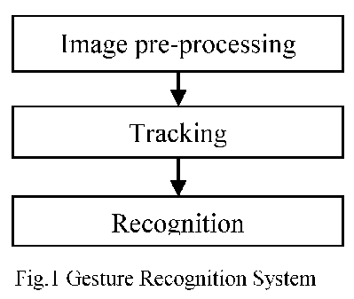

There Is Need To Convert RGB Image Frames Into HSV Images, Because It Is Related To Human Color Perception. HSV Features Helps User To Specify The Boundary Of An Image In Terms Of Hue And Saturation Value. Image Segmentation Is Used To Locate The Hand Object And Boundaries. In Convexity Hull Algorithm Adaptive Boosting Algorithm Use For Hand Detection And Can Use Hear Classifier To Train A Machine Learning Algorithm.

Initial Step Is To Segment The Image In Which Hand Is Located. After Segmentation, Contour Is Extracted And Finger Points Are Also Detected. Convexity Hull Is A Convenient And Appropriate Method For Finger Point Detection And Number Recognition. The Distance (0) Of Convex Hulls From Center Point Should Be Greater Than Radius(R) Of Inner Defects Circle. A Similar Study Can Be Done On English Alphabets As Well As Marathi By Using Contour Analysis Process.